**Project Design Phase-II**

**Data Flow Diagram & User Stories**

|  |  |
| --- | --- |
| Date | 03 October 2022 |
| Team ID | PNT2022TMID49040 |
| Project Name | Project – AI-Powered Nutrition Analyzer for Fitness Enthusiasts |
| Maximum Marks | 4 Marks |

**Data Flow Diagrams:**

**DFD-1(Login):**

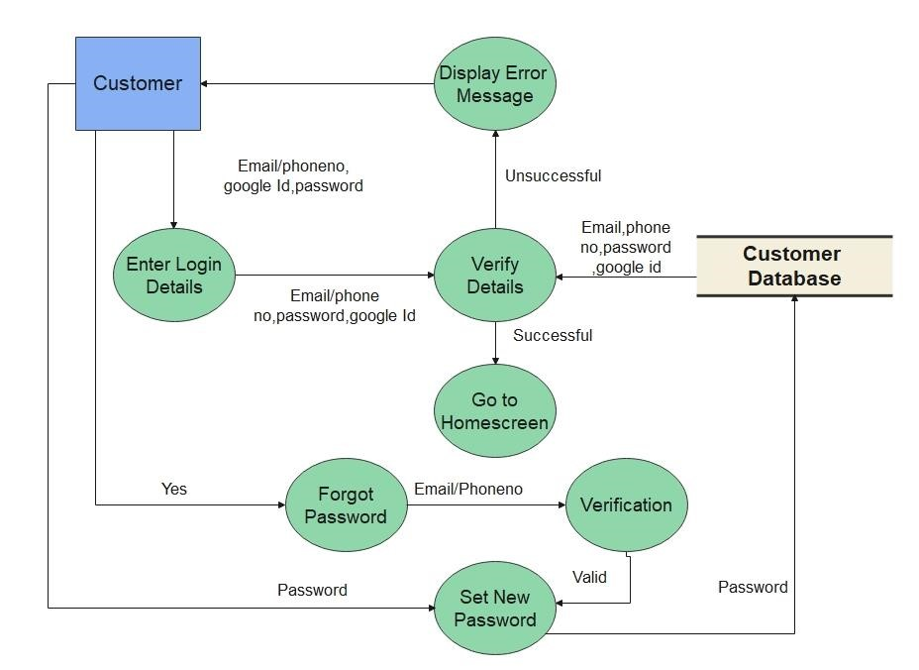

**DFD-1(Registration):**

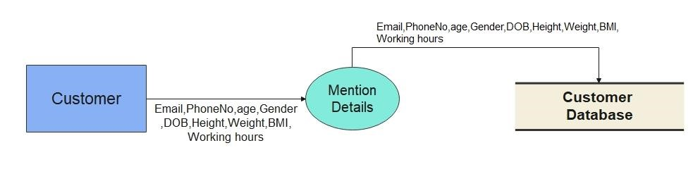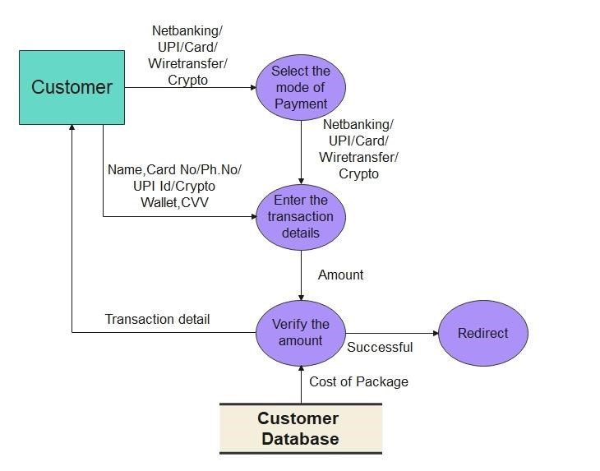

**DFD-1(Payment):**

**DFD-0:**

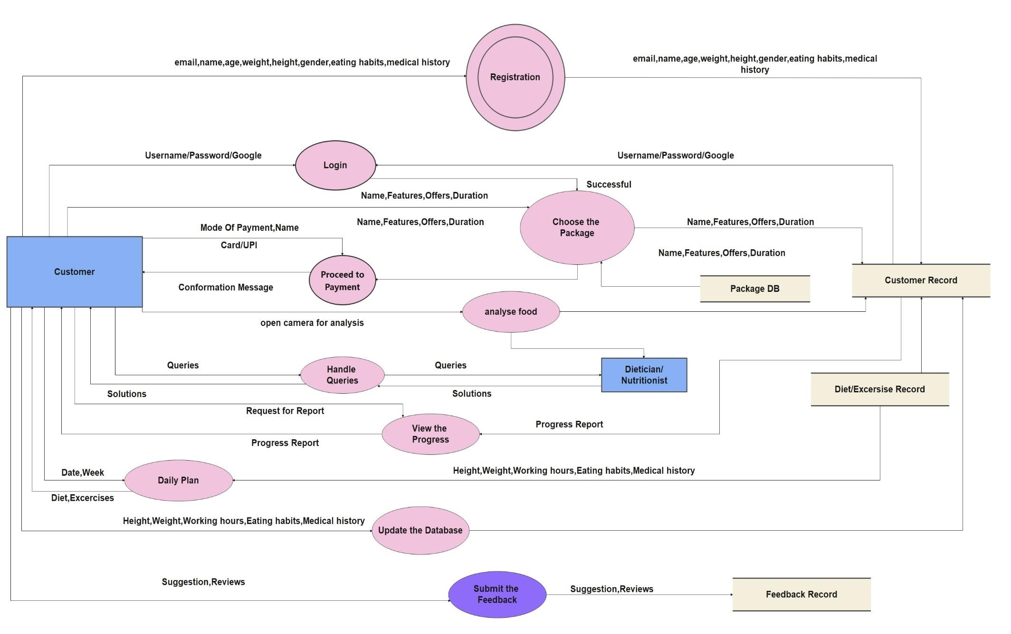

**User Stories**

Use the below template to list all the user stories for the product.

|  |  |  |  |  |  |  |
| --- | --- | --- | --- | --- | --- | --- |
| **User Type** | **Functional**  **Requirement (Epic)** | **User Story**  **Number** | **User Story / Task** | **Acceptance criteria** | **Priority** | **Release** |
| Customer | Registration | USN-1 | As a user, I can register for the application by entering my email, password, and confirming my password. | I can access my account / dashboard | High | Sprint-1 |
|  |  | USN-2 | As a user, I will receive confirmation email once I have registered for the application | I can receive confirmation email & click confirm | High | Sprint-1 |
|  |  | USN-3 | As a user, I can register for the application through Google | I can register & access the dashboard with Facebook Login | Low | Sprint-2 |
|  |  | USN-4 | As a user, I can register for the application through Microsoft | I can access the Dashboard with Microsoft. | Medium | Sprint-1 |
|  | Login | USN-5 | As a user, I can log into the application by entering email & password | I can login the Application by entering password | High | Sprint-1 |
|  | Main Interface | USN-6 | As a user I can view my calorie intake by clicking photo of the food I eat | Access the proper information about the nutrition and the calorie intake | High | Sprint-2 |
|  | Package DB, Dashboard | USN-7 | As a user I can choose variety of packages based on my requirement | Selecting an appropriate package | Medium | Sprint-2 |
| Customer Care Executive | Feedbacks DB , Tollfree number, chat bot | USN-8 | As a customer care executive, I collect feedbacks from customers | Maintaining proper environment for the customers | High | Sprint-2 |
| Dietitian | Customer Record | USN-9 | As a dietitian I provide daily plans for the betterment of the user | Positive results from user | High | Sprint-2 |
| Administrator | Dashboard | USN-10 | As an administrator I take care of all the operations which takes place in the app | Zero issues from the user | High | Sprint-2 |